 Assignment – 2

**CSE2010 - Advanced C Programming**

**Class Number:** VL2020210504705 **Slot:** L43+L4 **Name :** Prashanth.S **Roll :** 19MID0020

1) Write a C program to do the calculator’s basic operations using pointers. Also terminate the execution only based on user’s choice.

***Code :***

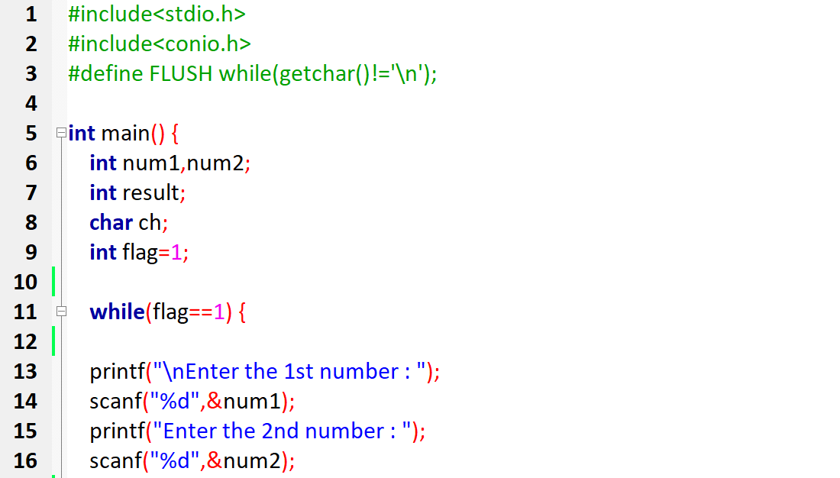  
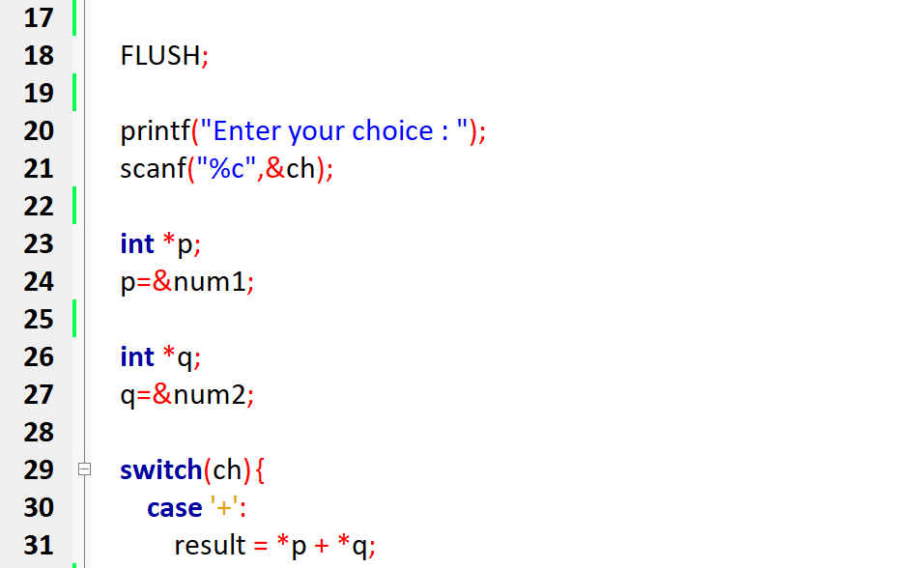

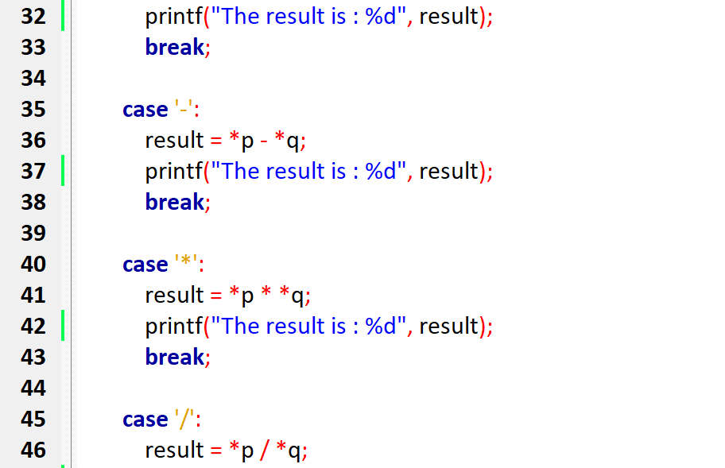

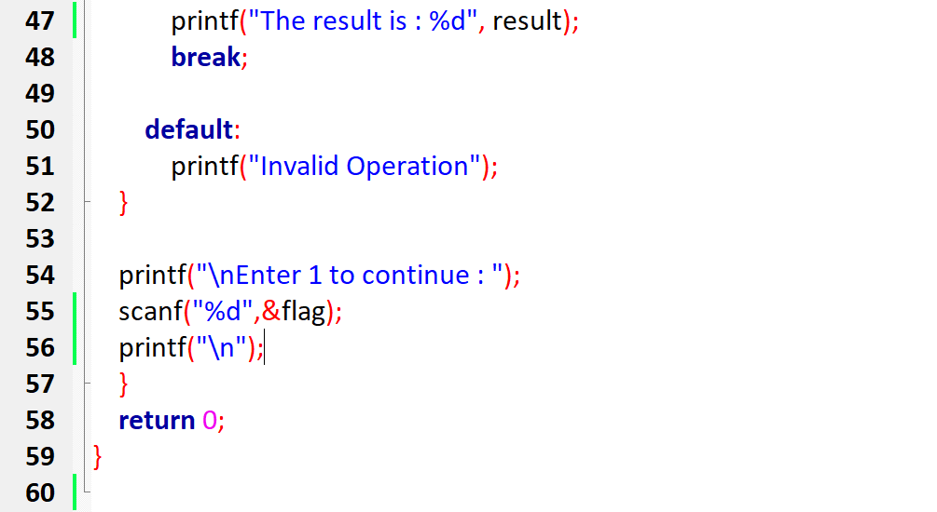

***Output :***

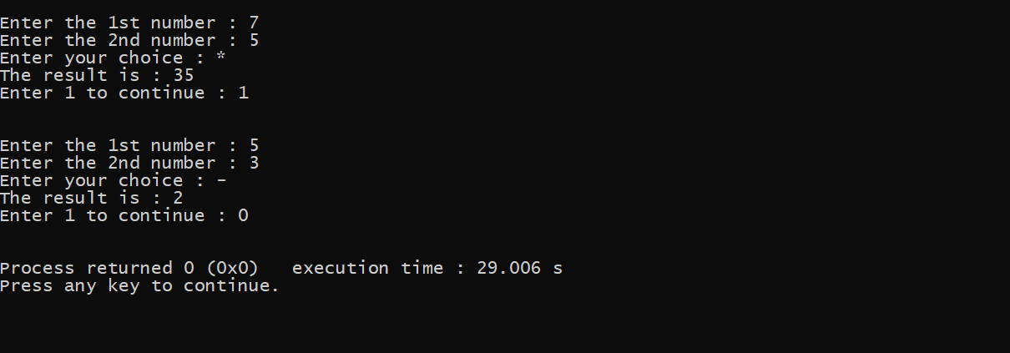

2) Write a C program to display the result of a student with N marks according to the VIT grading system using pointer to an array. (Note : calculate the average mark and fix the grade)

***Code :***

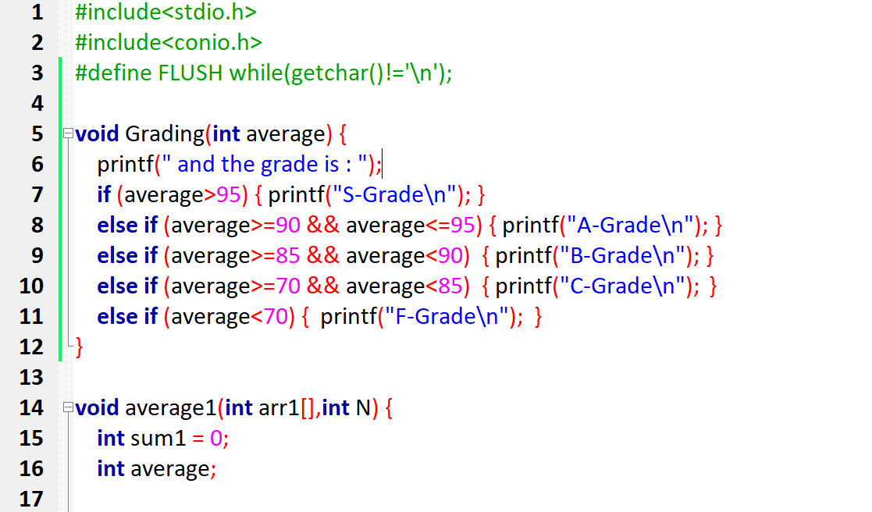

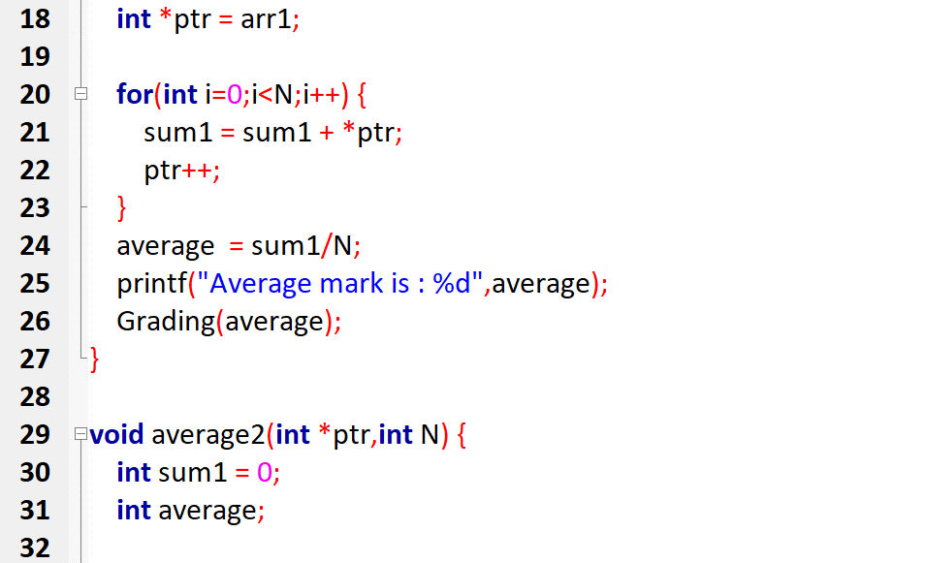

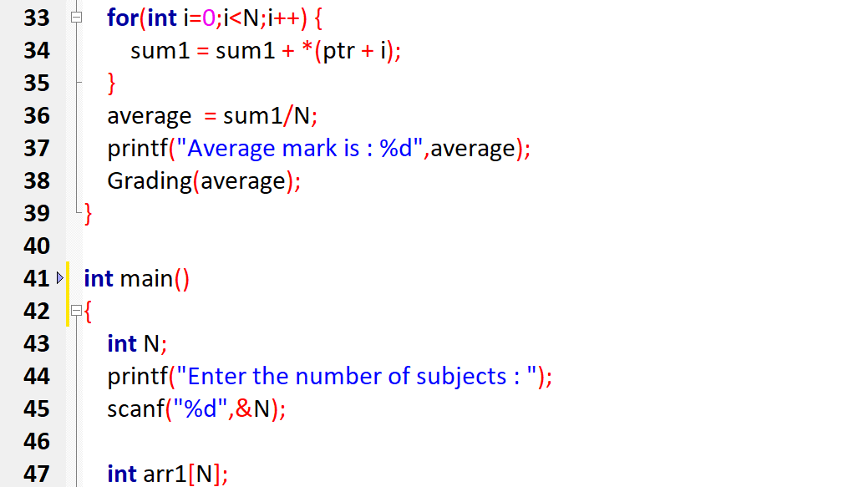

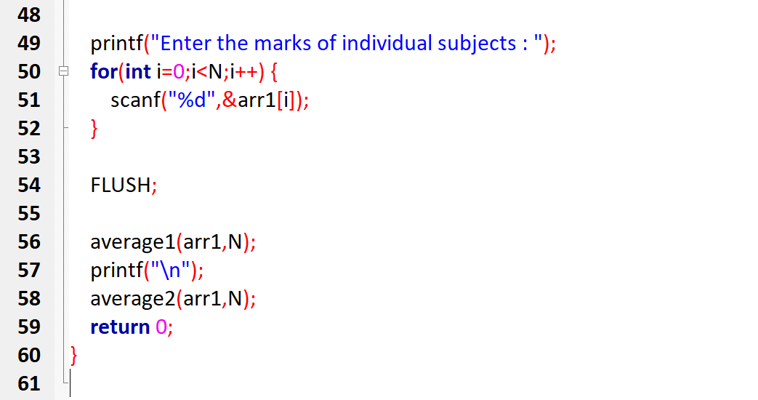

***Output***

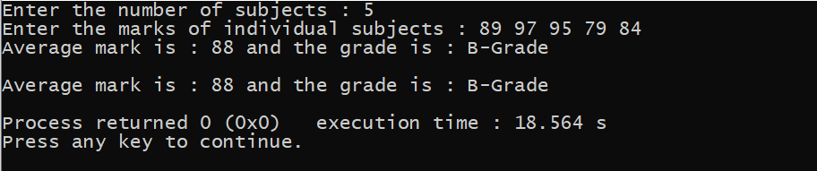

3) Repeat the same task in Q2 for M students using pointer to 2D array.

***Code :***

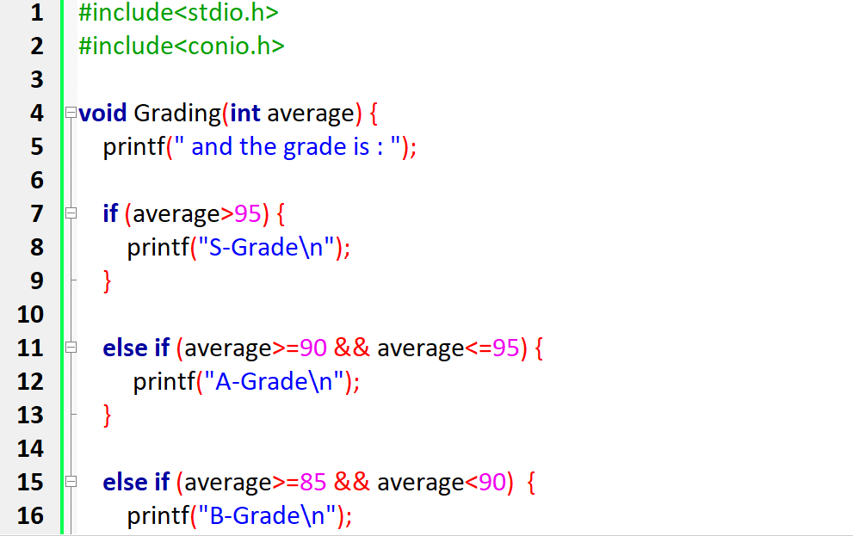  
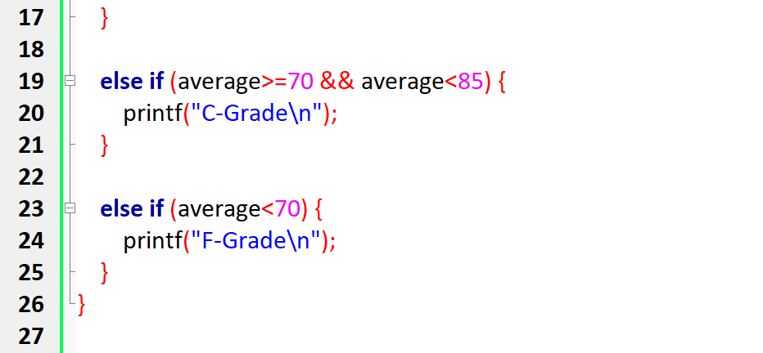

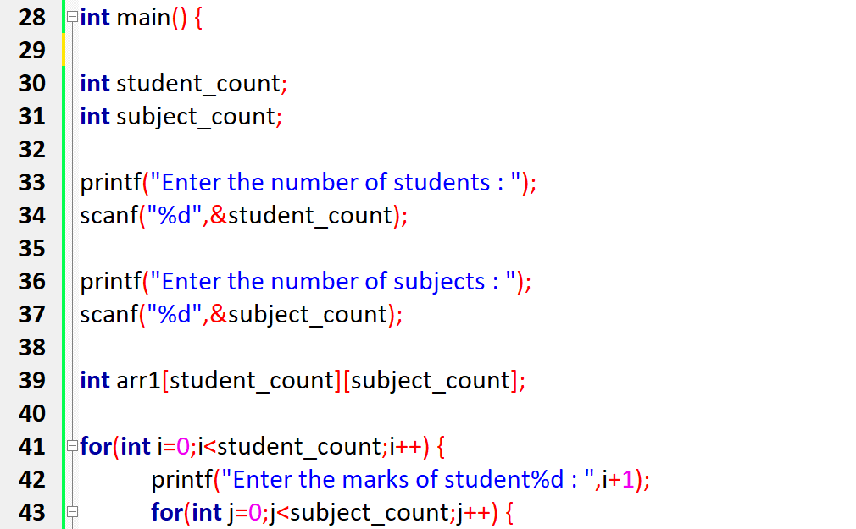

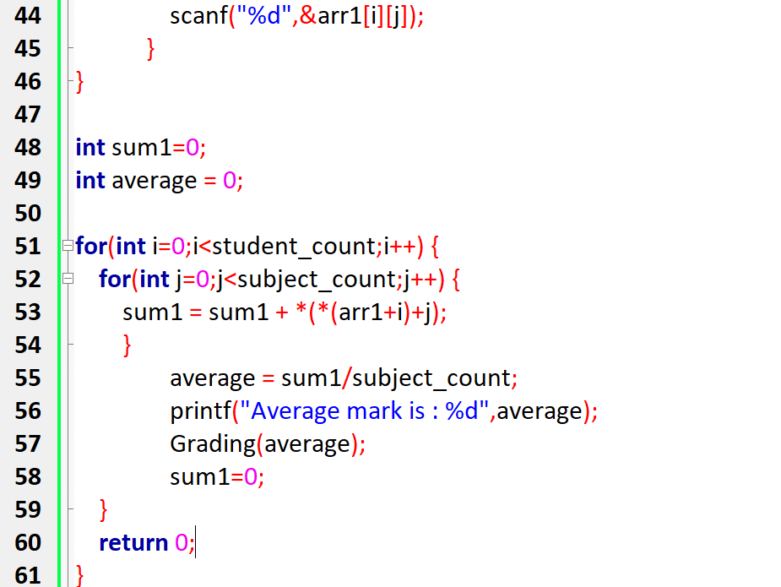

***Output :***

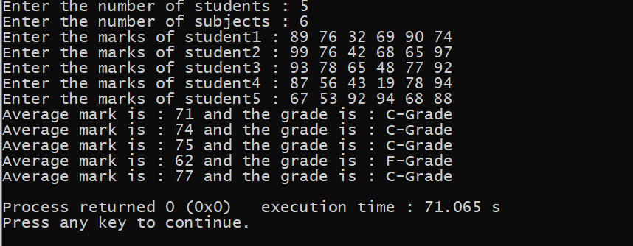

4) Write a C program to get your name and your friends name as input. Compare both of the names character by character and display the similar characters using pointers. Also display the count of similar and dissimilar characters.

**Code**

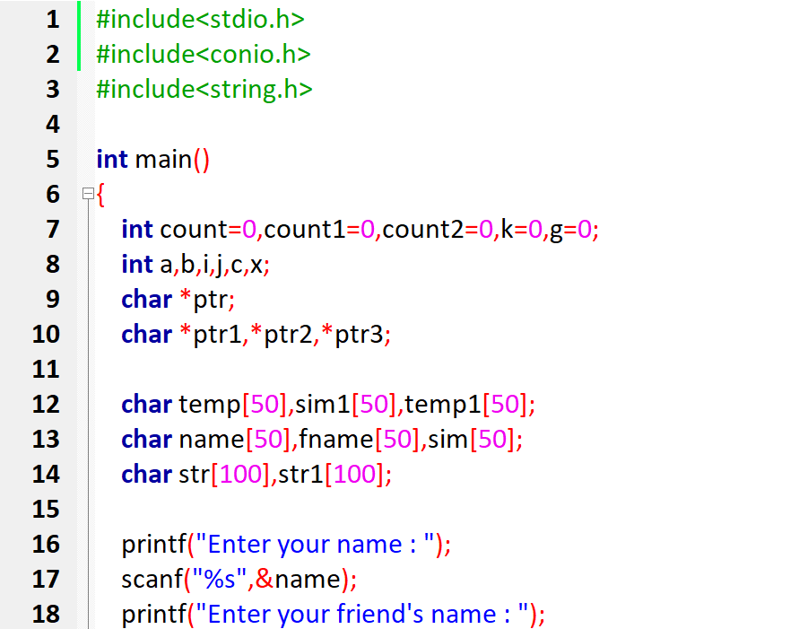

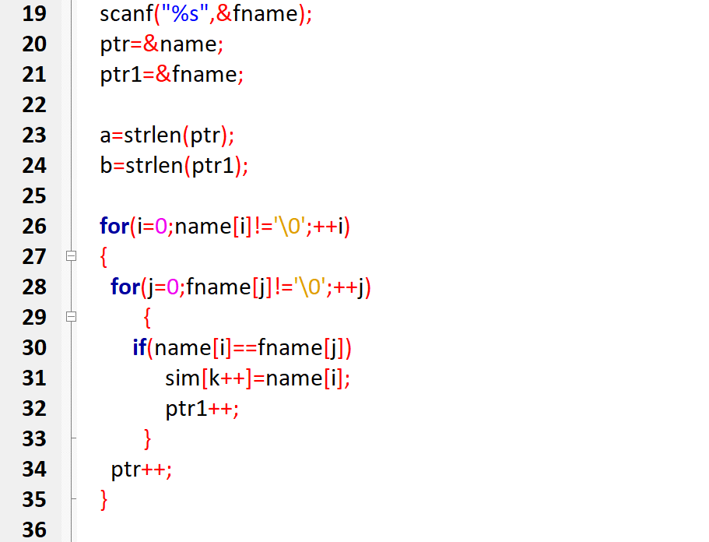

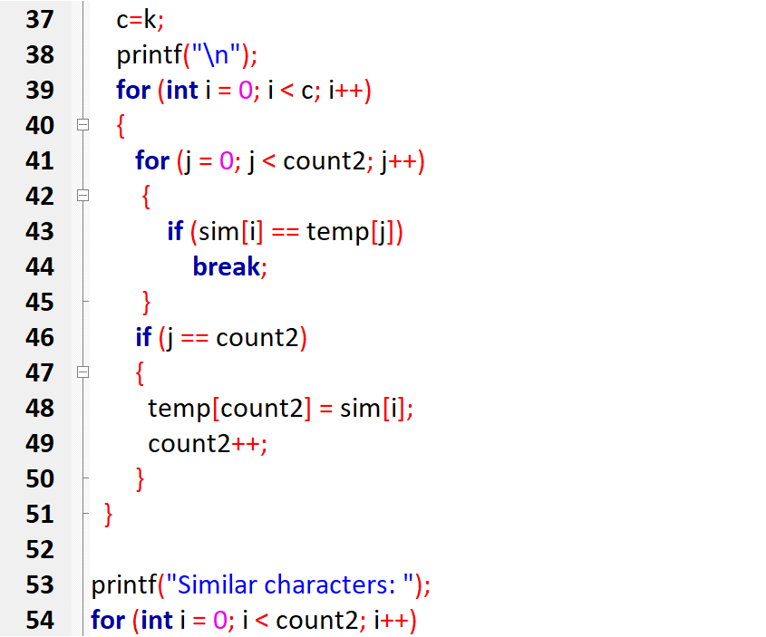

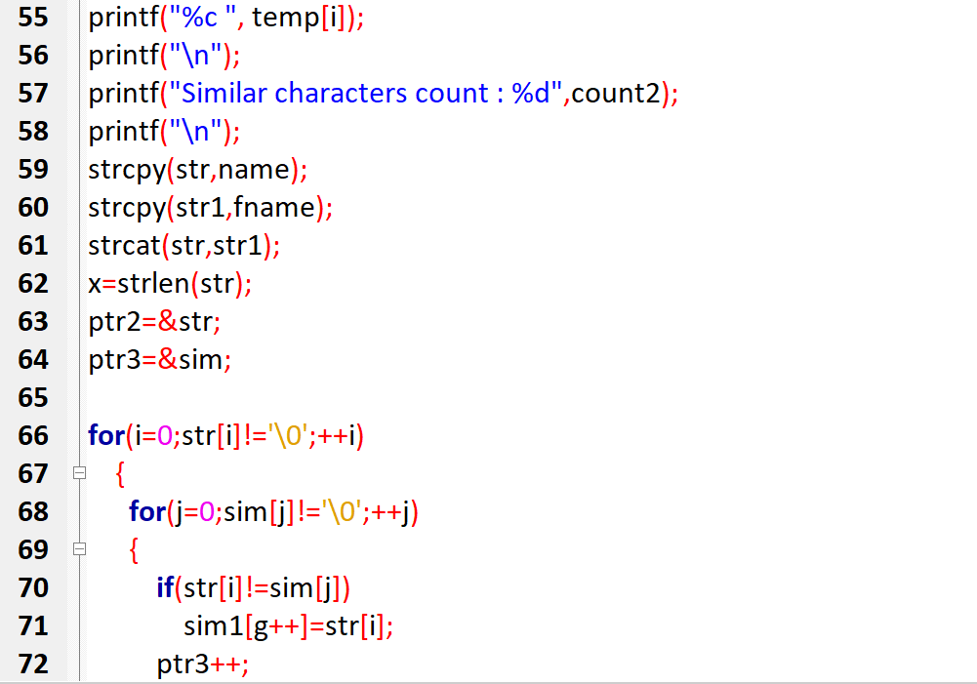

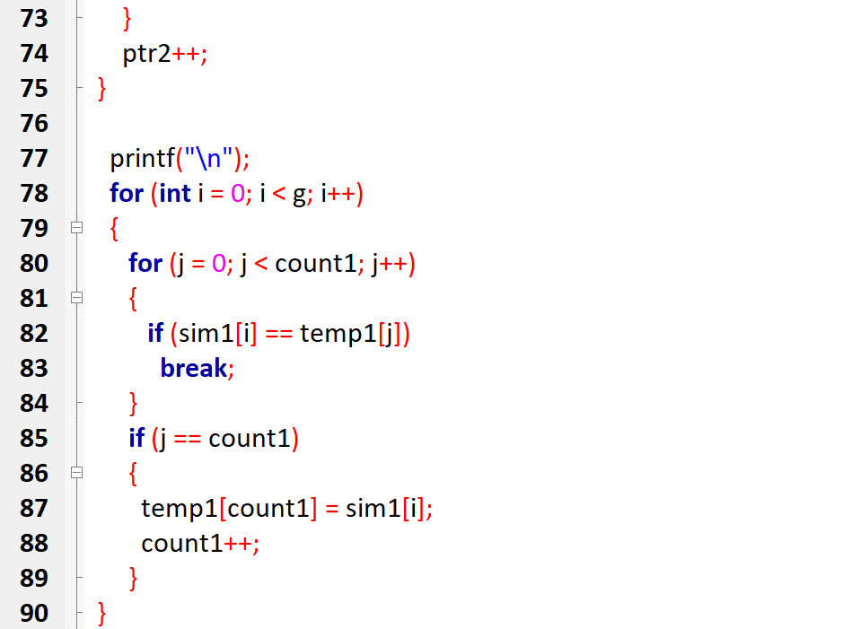

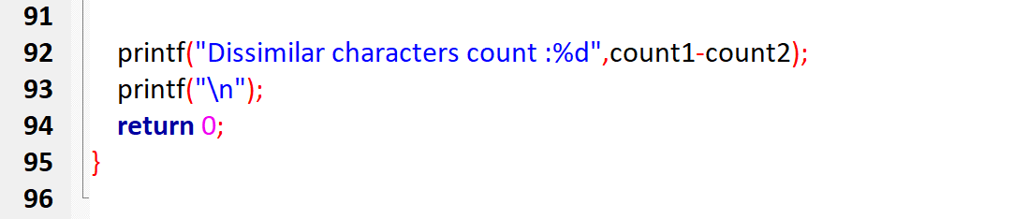

**Output**

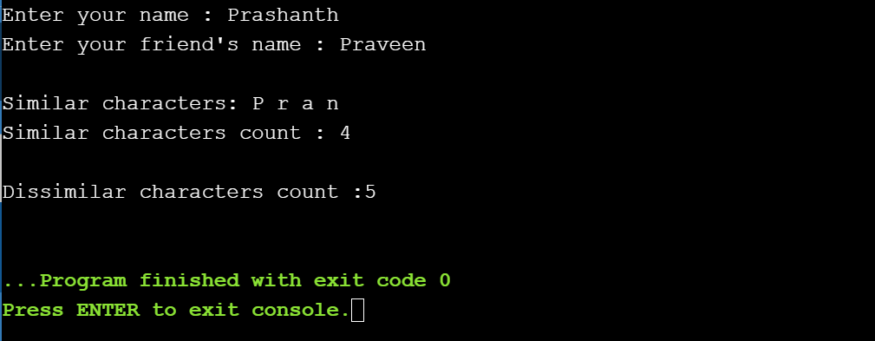

5)Write a C program to get the temperature of m days for n cities using dynamic 2D array. Calculate the maximum and minimum temperature of each day.

***Code :***

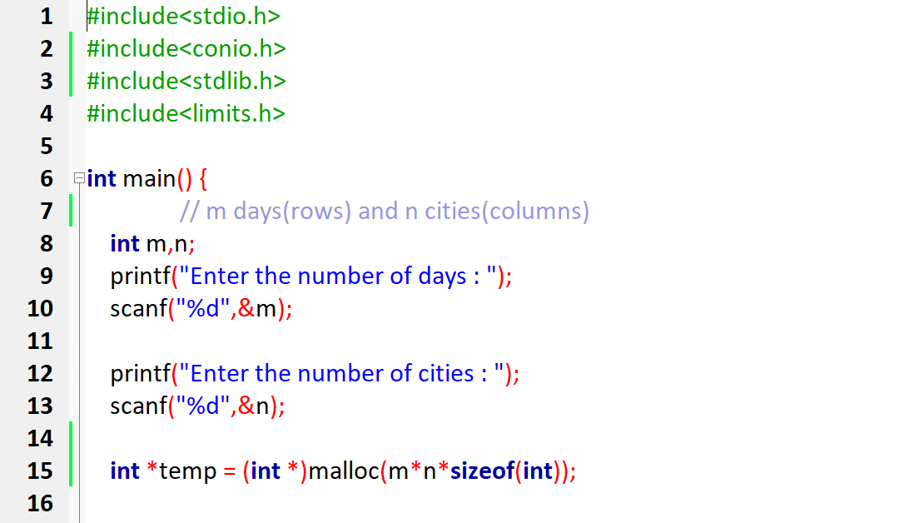

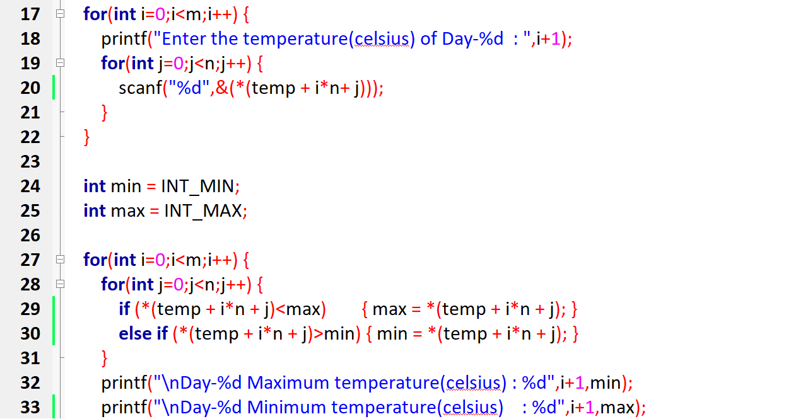  
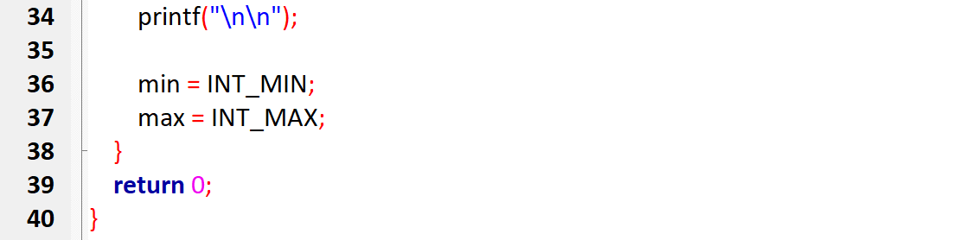

***Output:***

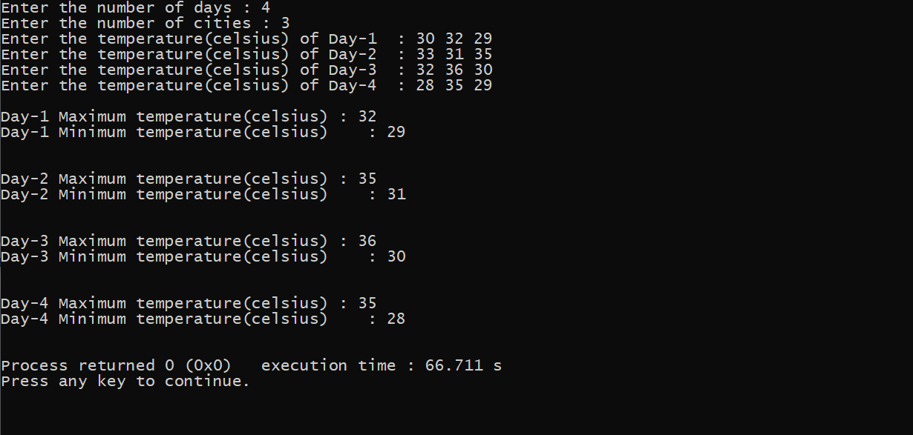

6) Tell me about how efficient your program is. (1 mark to show up your individuality, answer should be sound and sensible – Answers repeated no marks, so don’t share your answers)

**Code**

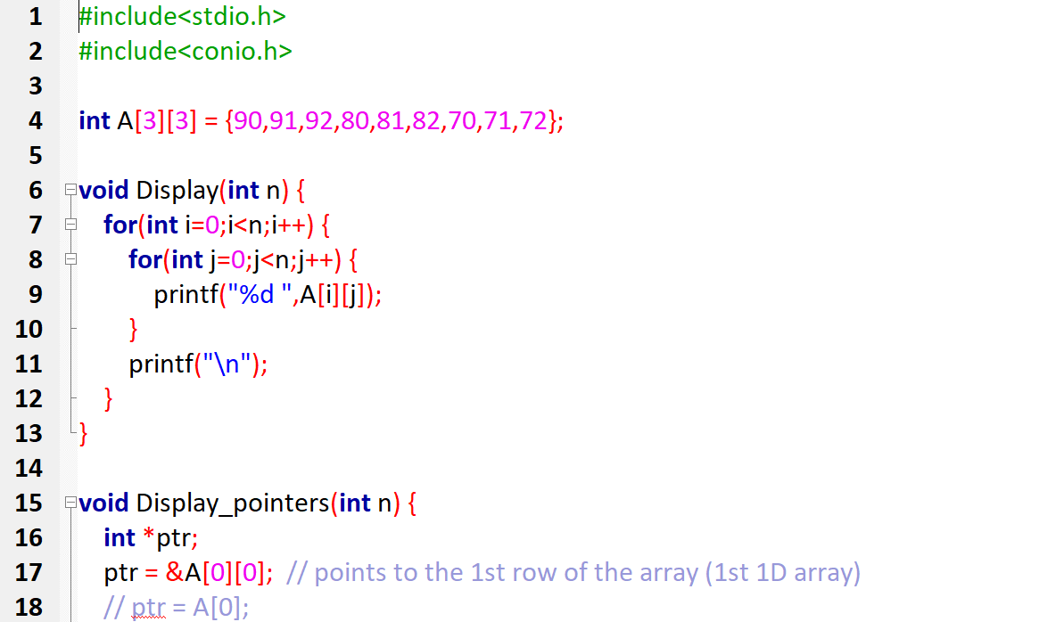

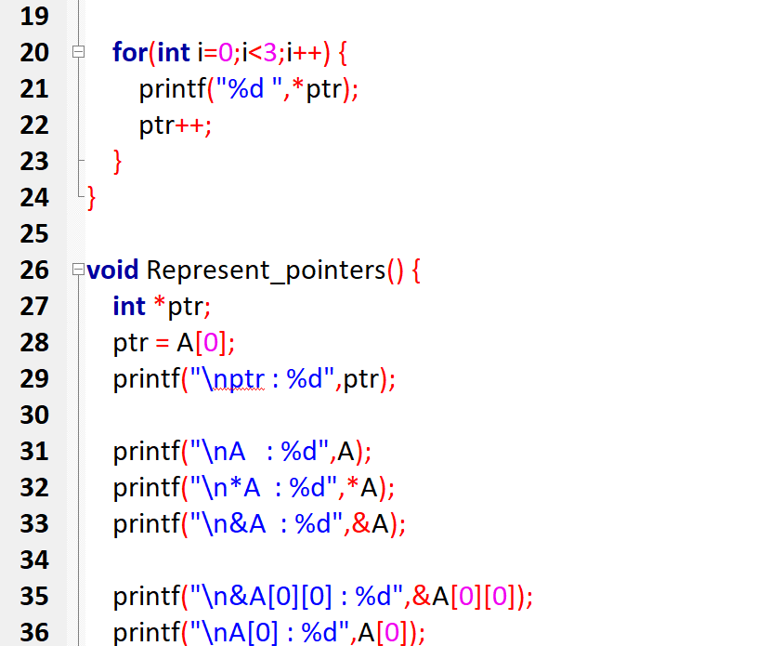

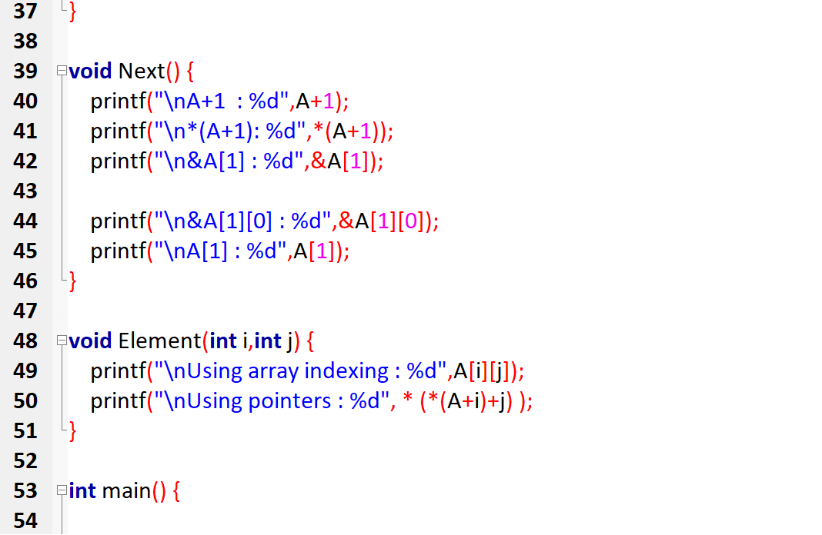

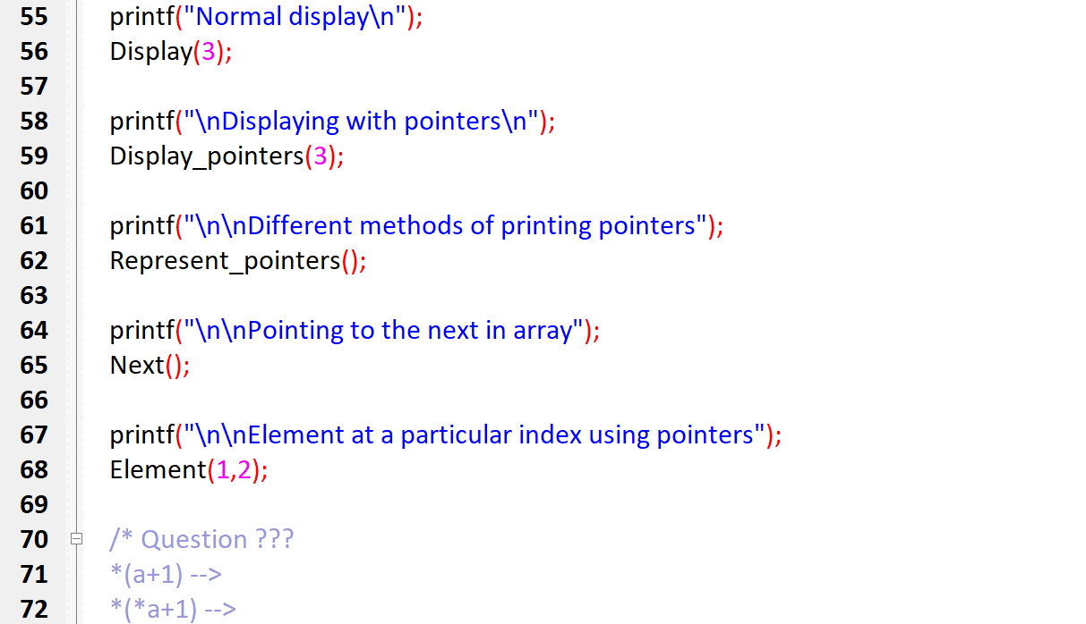

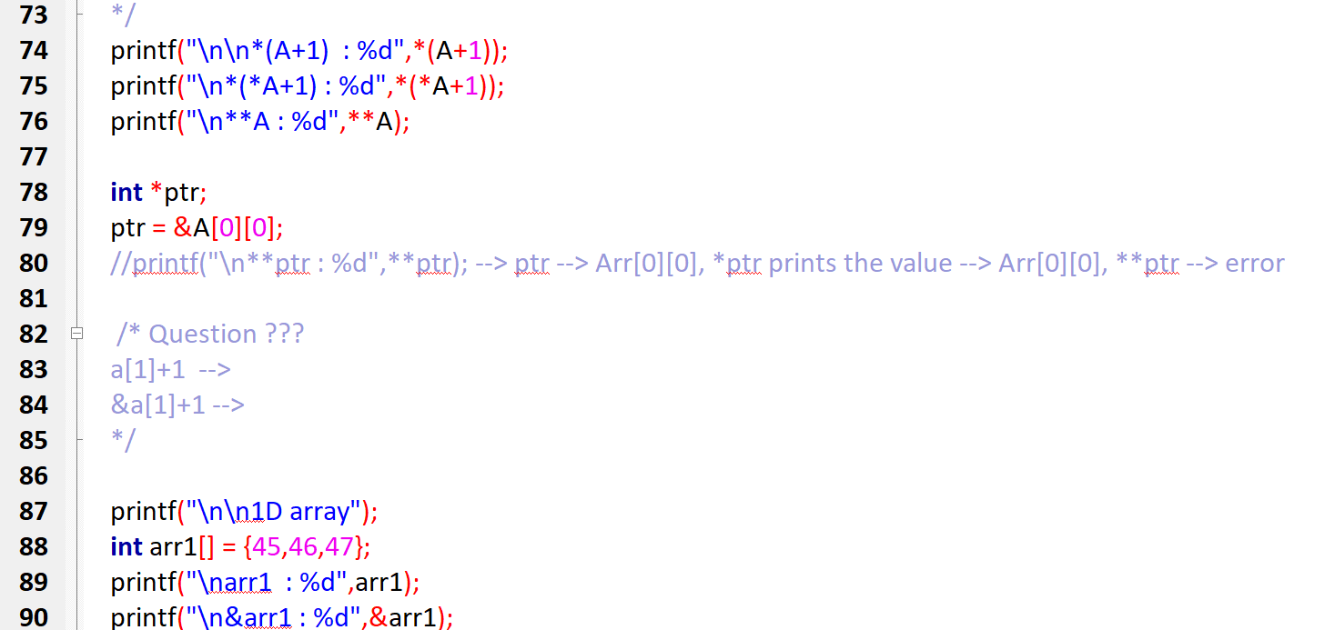

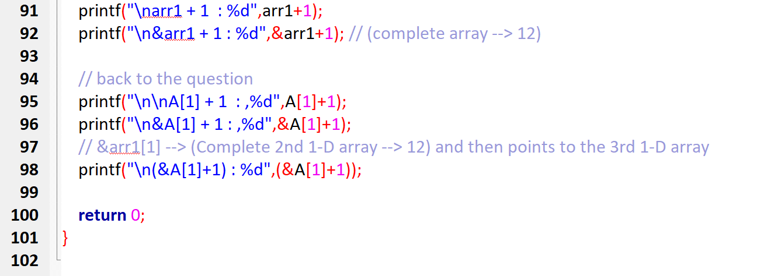

**Output**

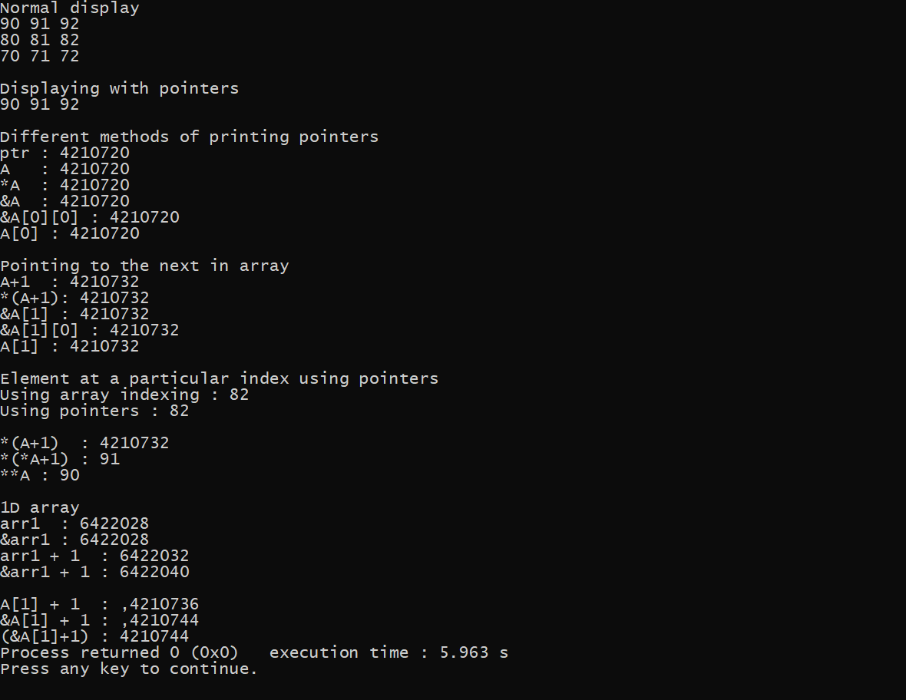

I used these array of pointers concepts in the 2nd and 3rd program.  
And also created dynamic array using pointers in the 5th program.

Github Link 🡪 <https://github.com/PrashanthSingaravelan/WinterSemester-2021/tree/main/CSE2010%20Advanced%20C%20programming/Assignment-2>